Creating and supporting the at-home reading coach—2 week plan

Before you begin:
Now more than ever, we need to engage the families of our students. Perhaps you’re feeling overwhelmed at how to do that? That’s where we come in. Springboard Collaborative has been helping teachers, just like you, build strong working relationships with families. This resource is everything you need!

Here’s how it works. Each day we’ve prepared a message you can send (through text, an app, email) to families. We’ve also provided a few ideas for how you might connect more personally with families--through videos, chats, facebook live events or phone calls. Don’t worry if you’re not doing it right--reaching out to families IS doing it right.

A final note: In this rapidly changing world, supporting families as they read together will help create some calm in the crisis. Connecting with your students and their families to make that happen is worthy and important work! You can do this!

Initial call home script:
Teachers, use this script as a guide to call families. This is an opportunity to connect, build relationships, and offer resources and support.

Introduction
Identify who you are and why you are calling. Keep it positive and upbeat!
- Hi! I’m ______. I am [student’s name] teachers from [school name]. I am reaching out to check-in and see how you are doing.
Tip: If there is no response, leave a voicemail. For privacy purposes, use only your name and title, do not reference the child’s name. Ask them to call you back at your preferred number.

Request permission
Ask if now is a good time to talk.
- “Do you have a few minutes to chat right now?”
- “Is this a good time to connect?”
Tip: If the family can’t talk now, as when a good time to talk is and call back then.

Check-in
Acknowledge the COVID-19 situation.
- “I know things are a bit strange right now, and wanted to let you know that I’m here as a partner.”
- “I wanted to check-in to see how and [student name] are doing. I miss our time together!”
Build relationships
Offer praise and compliment something the student has done a good job with.
- “Before we went on break, [student name] was working really hard on noticing the beginning letter sound.”
- “I wanted to let you know that [student name] has been doing a great job of retelling important events in a story.”
Tip: Be explicit and specific. Try to connect the praise to the scholar’s reading goal.

Offer support
Share the Springboard Collaborative resources that are available. Emphasize that they are free, and that families can do it!
- “Let’s keep building off that momentum. I wanted to share with you that I’ve found some great resources from Springboard Collaborative to help YOU be your child’s at-home reading coach.”
- “I know things are uncertain right now, and wanted to offer some supports.”
- “First, I encourage you to set a goal to spend time reading together and to make sure your child reads on their own EVERY DAY. Aim for 15 minutes of reading and talking together and 15 minutes of your child reading on their own (stretch that to 30 minutes if they’re 9 or older).”
- “When you’re reading together, I encourage you to try a different reading tip each week. This keeps your reading together time fresh and gives your child a new reading skill to focus on. Springboard explains each reading tip with a video and each day you have some guidance on how to do it a little differently.”
- “When you reach your goal for the week (or even the day) take a moment to celebrate! Do something fun together! Post on social media and tag me with #readfor15 or @SpringboardNTL so we can celebrate with you.”
Tip: This is a lot of teacher talk! Pause and leave space for questions and responses.

Collaborate on a goal or next step
Invite the family member to respond. Work together to set the goal.
- “What do you think?”
- “Is this something you would like to try?”
- “What feels like a manageable goal for you and [student name]?”
Tip: Let families know there are YouTube videos, Reading Tip summaries, and virtual workshops on Facebook on Wednesdays to support. See the resources page at Springboardcollaborative.org.

End on a positive note and create a “next step”
End the conversation complimenting the family member and explicitly naming
- “Thanks for taking time out of your day! This shows how much you care about [student’s name]. What is the best way for me to send you the plan?”
- “Thanks for chatting! I will check-in again next week. Keep up the great work!”
- “I appreciate you taking time to connect. Does this time work for you? I will call next week!”
Tip: Identify how you will share the materials with the family. Schedule a time to check-in next week.

Places to find free e-books:
- Local library (if you have a library card)
- https://www.raz-kids.com/ (You need to register but you get a free trial for 30 days)
- https://www.fbmarketplace.org/open-ebooks-all-ages-collection (need to register but it’s free)
- https://www.readworks.org/ (need to register but it’s free)
- https://www.starfall.com/h/
- https://www.wilbooks.com/free-resources-free-online-books
- https://freekidsbooks.org/subject/wordless/
- https://www.uniteforliteracy.com/
- https://newsela.com/ (need to register but it’s free)
- https://www.readworks.org/ (need to register but it’s free)

Week 1 : Take a a book walk
Monday
- Make a personal phone call, if you haven’t already.
- Message (text or email) to send to families:
Today when you take a book walk, try to “plant” one of the words from the book--that is talk about the word and what it means before you start reading.

Don’t have a book at home? Here are some e-books. [Or direct them to other texts]
- K: It’s Spring
- 1: Big Sister
- 2: Paleontology with Penelope
- 3: various options

[If your families have access to Raz-kids:]
- K: Carlos Counts Kittens
- 1: Maria Joins the Team
- 2: The Animal Bridge
- 3: Harold the Dummy

When your child is doing their alone time reading, remind them to “take a book walk” before they begin.

Have your child finish with 10 minutes of word games here (completely optional!).

Need some more help with this tip? I’ll send you a PDF of the reading tip summary. [See SpringboardCollaborative.org/resources page]

[Insert a personal note to families]

Tuesday
- Consider making a quick video of you taking a book walk through one of the read-aloud books your class enjoyed.
- Message (text or email) to send to families:
Today, when you take a book walk, try to “plant” one of the words from the book—that is, talk about the word and what it means before you start reading.

Don’t have a book at home? Here are some e-books: [Or direct them to other texts]
- K: Bear draws hats
- 1: Is this a Wild Animal?
- 2: Katie takes a Trip to the Grand Canyon
- 3: Ode to a Donut Oasis

[If your families have access to Raz-kids:]
- K: Do Not Eat That!
- 1: It’s Cinco de Mayo Carlos
- 2: Independence Day
- 3: Polar Bear’s Promise

When your child is doing their alone reading time, remind them to “take a book walk” before they begin.

Have your child finish with 10 minutes of word games here (completely optional!).

Need some more help with this tip? I’ll send you a PDF of the reading tip summary. [See SpringboardCollaborative.org/resources page]

Wednesday
- Offer to do a live book walk and read aloud to families this week on Facebook or Instagram. Consider doing it at various times so adults can join in.
- Message (text or email) to send to families:
Today, when you take a book walk, pretend to be the characters you see in each picture. Practice talking in silly character voices. See who can come up with the most interesting idea of what the characters are thinking.

Here are some e-books that may work for you:
- K: Animals Wear Hats
- 1: Mr. Bunny’s Carrot soup
- 2: The Four Friends
- 3: Draw Dragon Dot Eyes

[If your families have access to Raz-kids:]
  - K: Abby and Zots
  - 1: Happy Birthday, Snag
  - 2: The Igloo
  - 3: The Moon Bowl

When your child is doing their alone reading time, remind them to “take a book walk” before they begin.
Reading the first-grade e-books? Have your child read this book about veggies!
[Insert a personal note to families]

Thursday
- Video yourself retelling a story you read in class to your students. Use the pictures to retell it.
- Message (text or email) to send to families:
Today, when you take a book walk, focus on asking your child about the events in the story. Ask things like:
- How has the picture changed from the previous page?
- What do you think may happen next? Why do you think that?

When you’re done with the book walk, flip back through the pictures and say what will happen first, next, and last. Then read and find out if you’re right!

Here are some e-books that may work for you:
- K: I can do it
- 1: The Turnip
- 2: The Woman Runner
- 3: Cup Bow Snake Reflection

[If your families have access to Raz-kids:]
- K: Zot Goes to School
- 1: Zot Helps Out
- 2: Noise in the Night
- 3: The Trouble with English

When your child is doing their alone reading time, remind them to “take a book walk” before they begin.

Are you taking a book walk with your child? Post a video and tag us!

[Insert a personal note to families]

Friday
- Post a video message of one of your favorite days with your students.
- Message (text or email) to send to families:
Today, instead of doing a book walk, play “Walk me through your favorite day.” Ask your child to close their eyes and picture what happened on their favorite day. Then they can describe each part to you. They could also picture what will happen tomorrow (or next week or on a typical weekend day).

Next, read a story aloud to your child. Need an e-book? Find one here.

When your child is doing their alone time reading, remind them to “take a book walk” before they begin.

[Insert a personal note to families]

Week 2: I have another question

Monday
- This week’s reading tip is about helping families ask open-ended questions and have conversations with their children. Model that by texting each family and asking how reading is going!
- Message (text or email) to send to families:
This week, after you’re done reading a book together, you’re going to ask your child questions that lead to a conversation. Watch this video for some ideas.

Let’s try it. Read and ask your child, “What happened in this book? Was that surprising? Why or why not?”

Don’t have a book at home? Here is an e-book for your child.
- K: A Trip to the Zoo
- 1: Fair for Everyone
- 2: Grandma Always Listens
- 3: The Win-Win Club

[If your families have access to Raz-kids:]
- K: Elephants Car Wash
- 1: Cool as Cuke
- 2: Vampire Dentist
- 3: Charlene’s Sea of Cortez Journal

Remind your child to ask themselves two questions as they read on their own: 1) “What happened in this book?” and 2) “What does it remind me of?” Have your child finish with 10 minutes of word games here (completely optional!).

Need some more help with this tip? Check out the reading tip summary. [See SpringboardCollaborative.org/resources page]

Tuesday
- Record yourself reading aloud a book. Be sure to make a prediction and then return to your prediction in the end.
- Message (text or email) to send to families:
Today, you’re going to talk about predictions. First, look at the title (or take a book walk!) and take turns saying what you think the book will be about.

Then read the book. Talk about whether or not your prediction came true and why. Remember, it doesn’t really matter if your predictions were right—it’s just fun to make a prediction and have a conversation.

Don’t have a book at home? Here is an e-book.
- K: Sammy’s Picnic
- 1: Maria Makes a Snake (Create a free account)
- 2: Finding Grandpa’s House (Create a free account)
- 3: Amy’s Halloween Secret (Create a free account)

[If your families hace access to Raz-kids:]
- K: Maria’s First Halloween
- 1: Alistair’s Night
- 2: The Wild Swans
- 3: The Wall

Remind your child to ask themselves two questions as they read on their own: 1)What do I think is going to happen?” and 2) “What actually happened in this book?” Have your child finish with 10 minutes of word games here (completely optional!).

Need some more help with this tip? Check out the reading tip summary. [See SpringboardCollaborative.org/resources page]

[Insert a personal note to families]

Wednesday
- Retell a story you read aloud yesterday.
- Message (text or email) to send to families:
Today, take a moment to retell the story after you’re done reading. Read a short book and then ask your child to tell you what happened first, middle, and last. Then ask them, “How do you think the character felt in the end and why?” Remember, you want to have a conversation.

Need a book? Here are some good ones:
- K: A Trip to the Circus
- 1: The No Tail Cat
- 2: Sophie’s Rescue
- 3: Sophie’s Rescue

[If your families have access to Raz-kids:]
- K: Zot Learns to Play
- 1: Anna and the Dancing Goose
- 2: Jack’s Tale
- 3: Morty the Meany

Remind your child to ask themselves two questions as they read on their own: 1) “What happened in this book?” and 2) “What might the character be thinking?”
Invite your child to listen (and follow along, if they are old enough) to a story on https://www.storynory.com/ and then retell it to you!

[Insert a personal note to families]

Thusday
- Draw a picture of something the e-book linked reminds you of and text it to your families. Ask them to draw you a picture!
- Message (text or email) to send to families:
Today, you’re going to focus on helping your child make a connection to the story. After you read a story together, ask:
- Did this remind you of anything in your life? How so?
- This reminds me of________. How does this story connect to that?

Need a book? Here are some good ones:
- K: Pumpkin, Pumpkin
- 1: The Little Rooster
- 2: I Like to Go Exploring
- 3: A Sea Turtle Named Yertle

[If your families have access to Raz-kids:]
- K: Allie and Ollie
- 1: The Sisters C
- 2: Giant’s Tale
- 3: Two Kettles

Remind your child to ask themselves two questions as they read on their own: 1) “What happened in this book?” and 2) “What does it remind me of?” Have your child finish with 10 minutes of word games here (completely optional!).

[Insert a personal note to families]

Friday
- Host a live charades game! Or act out a few events from the story you read to students on Weds. Have kids text you their guesses.
- Message (text or email) to send to families:
Play charades! Instead of retelling the story you read today, take turns silently acting out different events in the beginning, middle, and end of the story. Try to act out the events in the order they appeared in the story.

Need a book? Here are some good ones:
- K: Dragon Goes to the Farm
- 1: First steps
- 2: Make Believe Box
- 3: Fixing My Sister’s Bike

[If your families have access to Raz-kids:]
- K: The Woodsy Band Jam
- 1: Blizzard Blackout
- 2: Cinderello
- 3: Wheeling the Snake

If you’re doing this with a nonfiction text, act out interesting things you learned. Here is a great place to find nonfiction texts.

Remind your child to ask themselves questions as they read today.

Invite your child to watch a clip from Planet Earth! Then they can tell you three interesting things they learned and why it was interesting.

[Insert a personal note to families]

Check back on Springboard Collaborative’s resource page for another 4-week coaching plan!

Learn the Strategy | Ask your child
Reading tip: Take a book walk  1. Touch the page: Encourage your child to point to all parts of the page, circle things with their fingers, etc. as they tell what they see.  2. Talk about the picture: Ask your child questions about specific things in the picture.  3. Say what happened: Discuss what your child is thinking about as they look at the pictures. What do these pictures tell us about the story?  For older kids, you can ask questions about the cover. Then flip over the book and read the back. Ask some more questions. Then read a paragraph or page in the beginning and the middle of the book. Discuss what your child “pictures” in their head.  This is a great way to get excited about a text and review some of the words or ideas your child will find before they actually read. Remember this strategy works for fiction and nonfiction texts! | - Tell me what you see in the picture.  - Where do you see that in the picture? Point to it.  - How has the picture changed from the previous page?  - What do you think may happen next? Why do you think that?  - What does this picture make you wonder?  - Who might the characters be?  For older kids  - What do you picture in your head for this part?  - What do you think is going to happen next?  - What else do you think this book may be about?
Interact & Play | Practice in the Real World
You and your child could pretend to be the characters you see in each picture. Practice talking in silly character voices. See who can come up with the most unique or interesting idea of what the characters are thinking or feeling! | Play “Walk me through your day.” Ask your child to close their eyes, picture what happened in their day. Then they can describe each part to you.  They could also picture what will happen tomorrow (or next week or a typical weekend day).
Flagging trouble spots
- Make sure you start reading from the beginning of the book. It’s fun to “guess” what the book says but even better to actually find out!
My thoughts and questions | 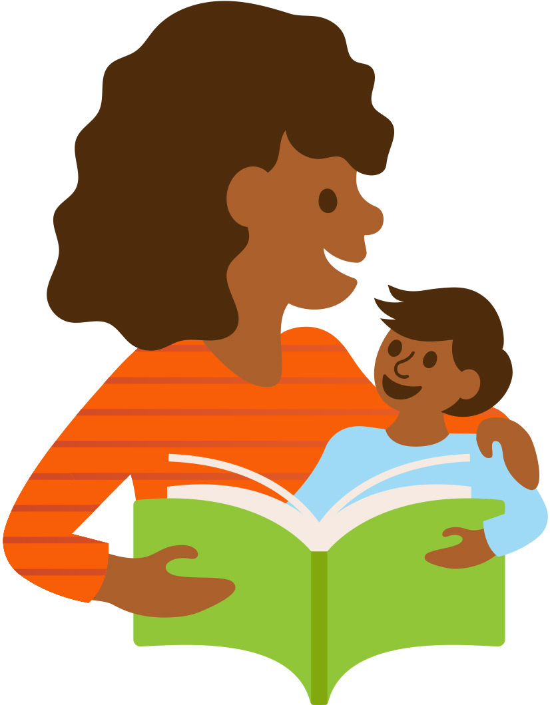

Learn the Strategy | Ask your child
Reading tip: I have another question  - Think about predictions: Help your child compare what they thought was going to happen to what did actually happen.  - Retell it: Talk more about what happened.  - Connect it to you: Help you child think of ways this story connects to their experience or other things they’ve read.  If we ask Did the character win in the end? our child will answer “yes” or “no” and that’s the end of it. But a question like How did the character win in the end? is “open-ended” and leads to a conversation. Talking deeper about topics it helps children understand texts deeper, too. | - Think about your prediction. What turned out to be true? What was different?  - What do you think will happen next? Why?  - What happened in the beginning? What happened in the middle? What happened in the end?  - Tell me more. What else happened?  - Did this remind you of anything in your life? How so?  - This reminds me of________. How does this text connect to that?
Interact & Play | Practice in the Real World
Play charades! Instead of retelling the story, take turns silently acting out different events in the beginning, the middle and the end of the story. Try to act out the events in the order they appeared in the story.  If you’re doing this with a nonfiction text, act out interesting things you learned. | Children can practice making connections between their life and the life of other people with characters in a book. And then you can extend it to real people—people you know, people in the news, even people in history. You might start the conversation this way:  I can imagine how that feels because…  I had something similar happen to me when…  I bet that person thinks/feels _____because if I was them…
Tips & tricks
- Almost any question can be turned into an “open-ended” question if you put a “why” on the end. For example, Do you like that book? Why?
- Use these questions before and during reading, too. It’s always the right time to ask open-ended questions!
My thoughts and questions

